CodeZERO replication PrOgramme
  - Application Form - Companies

What is CodeZERO

Project overview
CodeZERO is a three-year Horizon Europe research project aiming to co-create sustainable and zero-emission last-mile delivery and return solutions for ecommerce that align with consumers’ preferences while being sustainable for retailers, logistics operators and local authorities. Additionally, the project is focused on providing clear, consumer-friendly communication and developing tools for local authorities to promote eco-friendly behaviour.
CodeZERO is articulated in four phases:
- An ANALYSIS phase which provides (1) an analysis of existing delivery and return options and an understanding of how they are shaped by the needs and constraints of all involved stakeholders; (2) an in-depth intersectional analysis of various groups of on-line consumers to understand what are the features of delivery and return options making them attractive, with the aim to identify mechanisms to incentivize behaviour changes; and (3) develops an assessment framework to measure the impacts in the environmental, economic and social domains of new solutions.
- A DESIGN phase, in which CodeZERO engages in a co-design process involving retailers, transport operators, consumers and local authorities in developing (1) guidelines for retailers to raise awareness among customers; (2) a set of zero-emission and sustainable delivery and return options for retailers and transport operators; and (3) a toolset for local authorities to accelerate the transition towards sustainable solutions in last mile consignments in e-commerce.
- A TEST phase running 4 pilots in 4 different European cities in Italy, Netherlands, Belgium, and Norway to test a set of sustainable solutions identified in the previous phase with the aim to prove their feasibility, to fine-tune their design and to assess their impacts from the perspective of all stakeholders.
- A CONSOLIDATION phase where (1) CodeZERO outcomes are fine-tuned based on the lessons learned from real life applications, (2) requirements for up-scaling of solutions at European level are discussed (3) recommendations are formulated and (4) directions for future research are outlined.

Engagement with consumers and retailers’ associations, industry stakeholders, cities and researchers contributes to shaping project results.

Partners
The CodeZERO consortium consists of 15 partners from four different European countries, representing local city authorities, logistics service provider, e-commerce retailers, research institutions, universities, and a city network organisation.
- Belgium: City of Antwerp, Bpost, Eurocities, TORFS, VUB
- Italy: AMAT, IKEA Italy, So.DE, TRT
- Norway: City of Oslo, IKEA Norway, TOI
- The Netherlands: City of Utrecht, JUMBO, TNO

https://www.linkedin.com/company/codezero-project/

For further information please visit www.codezero-project.eu

CodeZERO Replication Programme

What are we looking for?
CodeZERO will select 8 replicator companies (on-line retailers or logistics companies) to participate in the CodeZERO Replication programme. We are looking for:

- 2 companies from Norway willing to replicate the solutions tested in Oslo
- 2 companies from the Netherlands willing to replicate the solutions tested in Utrecht
- 2 companies from Belgium willing to replicate the solutions tested in Antwerp
- 2 companies from Italy willing to replicate the solutions tested in Milan.

What are the CodeZERO solutions tested in the various cities?
See the description of CodeZERO solutions in Annex A.

How is the Replication programme structured?
The Replication Programme entails the following take-up and transfer activities:
- an information webinar
- a one-day study visit to one of the CodeZERO pilot sites (Oslo, Utrecht, Antwerp, Milan) coupled with a replication workshop
As a result, the Replicator Companies will develop:
- a Replication Plan illustrating whether and how they could replicate the visited CodeZERO measures in their context.

What is the timeline?
December 2025 | January 2026 | Spring 2026 | September 2026
Selection of  Replicator Companies | Information  Webinar | Site Visit  +  Replication Workshop | Replication Plan
Indicative dates:

Oslo: 4 - 5 March 2026
Utrecht: 14 - 17 April 2026
Milan: 26 - 29 May 2026
Antwerp: 18 - 19 June 2026

What is the content of the Replication Plan?
See Annex B for an indicative overview of the content of the Replication Plan.

Who is hosting the study visits?
The one-day study visits will be hosted by CodeZERO local partners:

Oslo | Utrecht | Milan | Antwerp
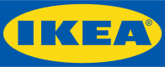 |  |  | 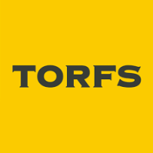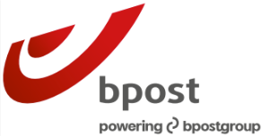

Why should your company apply to become a CodeZERO Replicator Company?
CodeZERO Replicator companies enjoy various benefits, including:
- Get a chance to meet and exchange with peers facing similar challenges
- Getting experts’ insights on the actual pilot implementation
- Being featured on the CodeZERO website and potentially European media outlets through a dedicated article/interview.

What will CodeZERO provide in terms of funding and support?
As a Replicator Company, you will:
- Receive financial support up to €525 to travel to the site visit and take part in the replication workshop.

What will be the tasks of companies involved?
As a Replicator Company, you commit to:
- Participate in the take-up and transfer activities (both online and in person), which include:
  - participating in the introductory webinar
  - participating to the one-day site visit and replication workshop organised by the pilot companies
  - develop a Replication Plan

Do you want to become a CodeZERO Replicator Company?

Apply now!

Please fill in the questionnaire below and send it back to annecharlotte.trapp@eurocities.eu and alyssa.harris@eurocities.eu by 30 November 2025.

Contact person:
If you have any questions, please contact Anne-Charlotte Trapp and Alyssa Harris at Eurocities:
Email: annecharlotte.trapp@eurocities.eu ; alyssa.harris@eurocities.eu

Questionnaire

General information
Your name |  | Position
Your e-mail address |  | Phone
Country
Company name
Company type | ☐ On-line retailer (own account deliveries)
Company type | ☐ On-line retailer (outsourced deliveries)
Company type | ☐ Logistics operator
Structure & size | ______Number of employees  ______% online sales*  ______% of sustainable deliveries*  *if possible to share.
Please choose one of the thematic focuses you would be most interested in | ☐ Last-mile delivery solutions
 | ☐ Communication strategies
Please provide a short description of your company (Max. 300 words)

Your last-mile delivery ecosystem
Please briefly describe the local logistics context you operate in (Max. 200 words)
What kind of last-mile delivery/return solutions for e-commerce do you currently offer?
(Max. 200 words)
Is your company planning to introduce alternative delivery/return solutions for e-commerce? If yes, please briefly describe them (Max 200 words)

Your communication strategies
Does your company communicate to customers the sustainability of your delivery/return solutions? If yes, how? (Max 200 words)
Is your company planning to introduce strategies to communicate the sustainability of your delivery/return solutions? If yes, please describe the measures you intend to adopt (Max 200 words)

Your interest in the project
Please explain briefly what you would like to learn from the CodeZERO project, which questions you would like to address ideally. (Max 200 words)

Annex A – Overview of CodeZERO Pilot actions

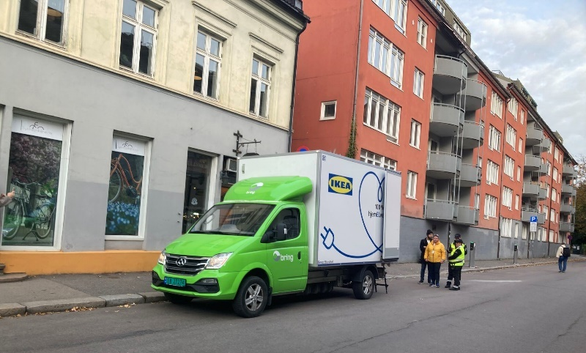
Pilot in Oslo: Click and Collect Near You
The Oslo Pilot will consist of mobile pick-up points for goods of up to 47kg in weight to keep the loading and unloading operations safe for a mobile pick-up point. The 47kg weight limit is intended to allow somewhat bulky goods to be delivered that might not fit in a parcel locker, while still being light enough that a single person can handle them to avoid the need for home delivery. Additionally, multiple packages larger than 47kg would potentially require significant volume in the delivery van and reduce the number of customers that could be served at the pick-up point.
Oslo and IKEA have implemented mobile pick-up points in 9 different locations. The locations were specified through close interaction between IKEA, The City of Oslo, and Bring (the transporter) to ensure they were convenient for customers while also alleviating safety concerns and conforming to rules and regulations on parking.

Partnership & Goal
- Collaboration between IKEA, the City Oslo, and Bring (logistics partner).
- Main objective: reduce traffic congestion in Oslo and provide more sustainable delivery solutions.
Concept: Click & Collect Near You (CCNY)
- A new service unique to Norway where customers pick up orders at central mobile collection points (i.e. vans acting as pick-up points) instead of waiting for home delivery.
- Designed for small and medium orders (max. 250 kg per order, 47 kg per package).
- Customers can reach collection points easily by walking, cycling, or stopping by on their commute.
Efficiency & Traffic Reduction
- CCNY enables and estimated 20–30 orders per hour, significantly reducing vans in Oslo city traffic.
- Fewer delivery vehicles needed.
Customer benefits
- Affordable pricing: NOK 99 for IKEA Family members.
- Convenient locations: near residential areas, workplaces, parking areas, gyms, football stadiums, and transport hubs.
- Customers can combine pick-up with their daily routines.
Implementation
- First pilot location: Grünerløkka, Oslo (launched on October 13th).
- Temporary use of parking spaces and curb side loading zones for pick up points
- 9 locations implemented across Oslo
- Flexibility: locations and timeslots can be adjusted depending on customer response (not convenient enough, to many customers driving to pick up, etc...)

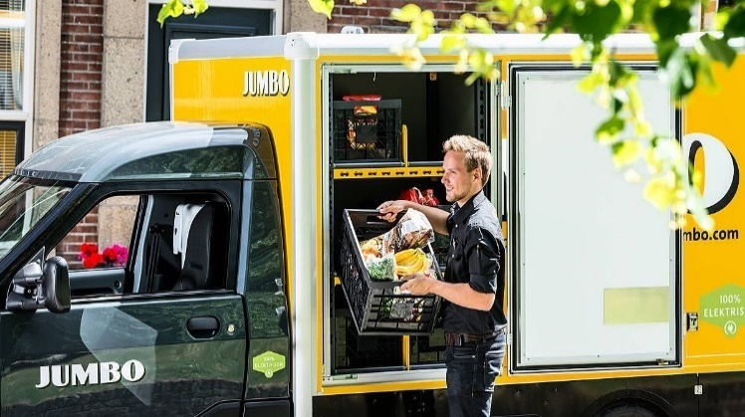
Pilot in Utrecht: Micro-hub for grocery delivery
The pilot in Utrecht will focus on testing solutions for sustainable grocery delivery in the city centre in which trucks face both weight and time restrictions.
Traditional van deliveries will be replaced by a stationary van acting as a micro hub inside the city centre. Orders consolidated into the van will then be distributed to customers via light electric vehicles (LEVs), such as cargo trailers or small e-vans.
The Municipality of Utrecht will provide access to a parking garage as the first hub location and will offer cargo bike trailers and LEVs to rent.

Partnership & Goal
- Collaboration between Jumbo and the city of Utrecht
- Explore sustainable solutions for grocery delivery in Utrecht’s city centre where trucks face weight and time restrictions.
- Ensure customers in difficult-to-reach or car-free/low-car neighbourhoods can still receive home deliveries.
Concept
- Replace direct van deliveries with a stationary van acting as a micro hub inside the city.
- Orders consolidated into the van are distributed to customers via light electric vehicles (LEVs), such as cargo trailers or small e-vans.
- Cargo bikes are excluded due to limited capacity for grocery orders.
Municipality Involvement
- Utrecht is creating new low-traffic, car-free areas, making this model relevant for future city planning.
- Municipality provides access to a parking garage (Paardenveld) as the first hub location.
- Municipality also offers a pool of cargo bike trailers and LEVs that companies can rent for pilots.
Data Analysis & Hotspots
- Order data from Jumbo (groceries) shows city centre areas with low current fulfilment due to restrictions.
- Delivery hotspots vary by time of day (morning vs. afternoon), influencing truck parking location.
- Practicality (parking, space for unloading, safe storage) also determines hub site selection.
Implementation
- Pilot will start with the parking garage as hub site.
- Vehicles tested are cargo trailer and light electric vehicle fleets.
- Hub setup allows safe storage of LEVs and avoids extra repositioning trips.

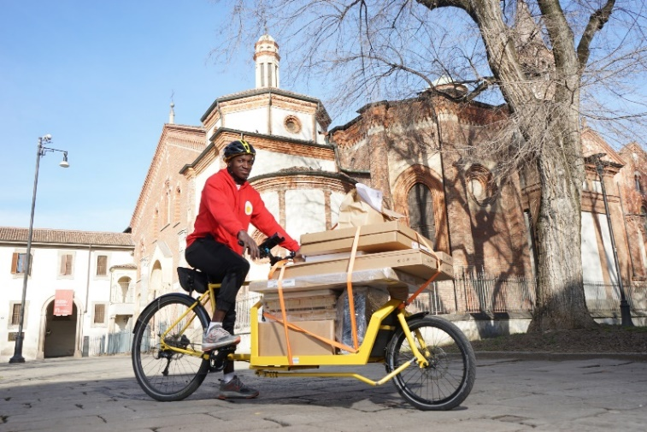
Pilot in Milan: Electric quadricycle in pedestrian and central area
CodeZERO pilot in Milan pilot will focus on enhancing deliveries by cargobike in the city centre.
While cargobike deliveries are already in use, the core idea of this pilot is testing refinements to the existing delivery model by using larger pedal-powered vehicles (e.g. tricycles, quadricycles) and increasing the adoption of these solutions by citizens.
At the heart of the solution(s) that will be piloted in Milan are:
IKEA Italia (e-tailer) is the Italian branch of the global home furnishings company, known for its flat-pack furniture, sustainable practices, and wide-reaching e-commerce operations.
So.De – Social Delivery (Logistics Operator) is a Milan-based logistics cooperative that provides last-mile delivery services using cargobikes. The organization not only promotes zero-emission logistics but also prioritizes social inclusion by employing workers from vulnerable or marginalized backgrounds under fair and stable working conditions.

Context
Milan regulations are strict (Limited Traffic Zone):
  - Area B = large low-emission zone.
  - Area C = restricted city centre with congestion and environmental controls.
  - Fashion District (Quadrilatero della moda) has even stricter rules:
    - From 2025: vans allowed only between 9–11 AM and 8 PM-1 AM.
    - From 2026: no entry even for scooters/motorcycles.
These restrictions make the Fashion District an ideal testing ground for cycle logistics.
Partnership
Collaboration between IKEA and So.De (logistics partner).

Concept
Communication strategy
  - Add pop-ups at e-commerce checkout to highlight the social and environmental impact of cargo bike deliveries.
New Vehicle Testing
  - Test an electric quadricycle or tricycle for higher-density delivery areas.
  - Operated in a co-loading model: combining IKEA orders with other clients’ parcels to increase load factor.
  - Focus: rider feedback (safety, drivability, reliability) + logistics KPIs (load factor, km travelled, cost per delivery, service performance).
Implementation
- Redesign ZIP codes: identify zones in the historic city center with high delivery density and accessibility (not only the Fashion District but nearby areas too).
- Testing timeline:
  - Jan–Mar 2025 → Deliveries in new ZIP codes using standard cargo bikes.
  - Apr–Jun 2025 → Deliveries in same areas using quadricycles.

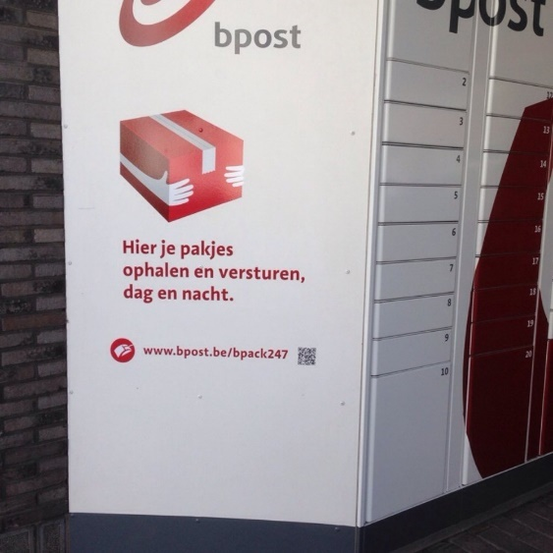
Pilot in Antwerp: Lockers and communication campaigns
The pilot in Antwerp focuses on the deployment and further use of parcel lockers. The infrastructure will be deployed in the postcodes 2000, 2060, 2018. In that area, bpost already operates 21 parcel lockers and 31 manned PUDO points today. By expanding the network, the choice of location of these new infrastructures will meet several objectives.
First, the pilot project aims to facilitate the accessibility to parcel lockers for online consumers. Currently, the network can reach a potential of 70% consumers within a radius of up to 400 metres from a PUDO point, including parcel locker. With the pilot, the goal is to reach 85% consumers within a radius of 400m by adding 13 additional lockers.
Second, the pilot wants to stimulate social inclusion by locating parcel lockers at the premises of retirement homes. The goal is therefore to test the effect of such integration in a minimum of five different sites where parcel lockers can reduce loneliness.
Third, the capacity of parcel lockers is increased in high volume areas in order to assure delivery according to preferences.
Besides infrastructure development, the pilot also aims to encourage online shoppers to opt for delivery to parcel lockers instead of home deliveries.
Partnership and Goals
- Collaboration between bpost, TORFS and the City of Antwerp.
- Expand the parcel locker network.
- Shift customer behavior from home delivery to pickup points/lockers.
- Promote active mobility (walking, cycling) for parcel collection.
- Encourage inclusion by placing lockers near retirement homes for easier access by families.
Implementation details
- Locker Deployment: Expand the pick-up points from a network of 21 parcel lockers and 31 manned PUDO points in 2025 by adding 13 new lockers in order to reach 85% of consumers in a radius of less than 400m in the three Antwerp postal codes (2000, 2160, 2180).
- Placement: All lockers are on private property.
Communication & Awareness
- Strong emphasis on behavioral change campaigns.
- City of Antwerp: target 10,000 social media views to promote out of home delivery.
- bpost & partners:
  - National communication campaign highlighting lockers as the first-choice delivery option.
  - Personalised nudges via emails & app notifications, especially for customers with frequent failed deliveries, encouraging them to select lockers or pickup points instead of home delivery.
  - Feedback collection: app/email surveys asking customers how they travel to lockers to monitor sustainable mobility uptake.

Annex B – Content of Replication Plan (indicative)
The Replication Plan will be a short word document (indicatively from 5 to 10 pages) addressing the following points:

Description of the Replicator Company
- Company name
- Type of company
- Location
- Description of the company
Description of the last-mile delivery ecosystem
- Local logistics context the company operates in
- Type of last-mile delivery/return solutions for e-commerce currently offered
- Plans to introduce alternative delivery/return solutions for e-commerce (if any)
Description of customers’ expectations
- Expectations/needs of company’s customers in terms of delivery/return solutions for e-commerce
- Barriers (if any) faced in meeting such expectations/needs
Description of communication strategies
- Company’s strategy to communicate to customers the sustainability of your delivery/return solutions
- Plans to introduce strategies to communicate the sustainability of your delivery/return solutions (if any)
Description of experience with innovative sustainable deliveries
- Description of innovative sustainable delivery/return solutions for e-commerce tested by the company in the past
- Reason(s) for implementing/non implementing them
Description of replicability of CodeZERO DELIVERY SOLUTION
- Is the CodeZERO Pilot delivery solution replicable in the company’s context?
- If yes:
  - Description of the factors enabling the implementation of the delivery solution in the company’s context
  - Description of any foreseen barriers to the implementation of the delivery solution in the company context
  - Suggestions on how overcoming barriers
- If not:
  - Description of the barriers hindering the implementation of the delivery solution in the company’s context
  - Suggestions on how overcoming barriers
Description of replicability of CodeZERO COMMUNICATION STRATEGY
- Is the CodeZERO Pilot communication strategy replicable in the company’s context?
- If yes:
  - Description of the factors enabling the implementation of the communication strategy in the company’s context
  - Description of any foreseen barriers to the implementation of the communication strategy in the company context
  - Suggestions on how overcoming barriers
- If not:
  - Description of the barriers hindering the implementation of the communication strategy in the company’s context
  - Suggestions on how overcoming barriers
Best practices and lessons learned
- Any best practices on last mile delivery/return solutions for e-commerce and/or communication strategies worth to share with CodeZERO stakeholders
- Any lessons learnt / “worst practices” on last mile delivery/return solutions for e-commerce and/or communication strategies worth to share with CodeZERO stakeholders?

